ATSP CODE:

OPERATIONAL RISK ASSESSMENT AND MITIGATION FOR UAS OPERATIONS IN CONTROLLED AIRSPACE

This document defines additional risk mitigation measures for UAS operations planned to be carried out in controlled airspace for a specific ConOps, agreed in writing between the UAS operator and the Air Traffic Service Provider (ATSP), and establishes the coordination procedure required to carry out the aerial activity. Once validated by ENAIRE, this document provides evidence of the operational coordination in the strategic phase, in compliance with Article 42.2.b of Royal Decree 517/2024.

The aerial activity of the UAS operator must comply with the provisions herein. Any operation that does not comply with the established conditions will require a new operational risk assessment and mitigation, and coordination with the ATSP, without prejudice to any sanctions that may result from the non-compliance with the agreed measures.

# DETAILS OF THE UAS OPERATOR AND OF THE AIR TRAFFIC SERVICE PROVIDER

Contact information for the purposes of strategic coordination and evaluation of this document between both parties:

* 1. UAS operator details

|  |  |
| --- | --- |
| UAS operator registration number | To be completed by the operator |
| Name or company name | Name or company name |
| Contact person | Full name (position) |
| Telephone | Tel |
| E-mail | E-mail |

* 1. Details of the air traffic service provider

|  |  |
| --- | --- |
| Name or company name | ENAIRE |
| Contact | [[ENAIRE Planea](https://planea.enaire.es/nsf/#/login) / drones.safety@enaire.es / [website](https://www.enaire.es/servicios/drones/todo_lo_necesario_para_volar_tu_dron/como_volar_drones_en_zonas_geograficas_de_enaire)](https://planea.enaire.es/nsf/#/login) |

# Definition of the concept of operations (CONOPS) and scope of application

* 1. ConOps

The operations must conform to the following ConOps:

|  |
| --- |
| SPECIFIC CATEGORY  STS-ES-01 |
| VLOS |
| DAYTIME and/or NIGHTTIME |
| INSIDE CONTROLLED AIRSPACE |
| INSIDE AND/OR OUTSIDE GENERAL UAS GEOGRAPHICAL ZONES FOR OPERATIONAL SAFETY REASONS IN THE VICINITY OF AERODROMES[1] |
| UAS with C5 class marking / MTOM < 10 kg |
| MAXIMUM ALTITUDE XX m, except for obstacles |

This document applies to aviation operations with unmanned aircraft that adhere to the following parameters:

* The UAS operator is registered.
* The operation falls under a specific category and standard scenario STS-ES-01.

|  |  |  |  |
| --- | --- | --- | --- |
| **Category** | **Operational restrictions** | **UAS MTOM** | **Class marking** |
| Specific STS-ES-01 | - In controlled land areas in populated areas without overflying any gatherings of people.  - The operation will be carried out within 100 m of the remote pilot.  - Maximum height of 120 m AGL. For flights around an obstacle, the RPAS may be flown around it at a maximum horizontal distance of 50 m and 15 m above it.  - The maximum height of the operational volume shall not exceed the maximum permitted height mentioned above by more than 30 m.  - The unmanned aircraft shall not carry dangerous goods.  - The operation is not carried out from moving vehicles. | < 10 kg | C5 |

* Operations will take place in **controlled airspace.**
* They will be carried out **inside/outside** **general UAS geographical zones for operational safety reasons** in the vicinity of airports and heliports defined in the annex to this document.
* The UAS operations will **not** be autonomous.
* The operations will be carried out within the pilot's visual range (**VLOS**).
* The operations may be **daytime and/or nighttime**.
* The operation will **not** be carried out from moving vehicles.
* The operation will **not** be carried out with a tethered unmanned aircraft (captive aircraft). // The operation **may** be carried out with a tethered unmanned aircraft (captive aircraft) up to 50 m.
* The operation will **not** be carried out with an FPV system. // The operation **may** be carried out with an FPV system. For these operations, observers will be available to ensure VLOS.
  1. Scope of application

This coordination is valid in the controlled airspace and aerodrome information zone managed by the aerodrome ATS units:

|  |
| --- |
| Units where ENAIRE provides air traffic services |

or

|  |  |
| --- | --- |
| **Airspace type** | **Remarks** |
| Example: CTR Madrid |  |

# DESCRIPTION OF UAS AND SEMANTIC MODEL

This section lists the UAS models that the operator will use and describes the semantic model with the maximum geographical area of the flight and the minimum contingency volume and air risk margin that will be maintained.

* 1. Description of the UAS

The table below lists the models of UAS that will be used in the operations of the ConOps described earlier:

|  |  |  |  |  |  |  |  |  |
| --- | --- | --- | --- | --- | --- | --- | --- | --- |
|  | Manufacturer and model of the UAS | Configuration  (Multi-rotor) | Class marking (if applicable) | MTOM (kg) | Size (m) | Speed (m/s) | Impact energy (joules) | Flight time (min) |
| UAS 1 |  |  |  |  |  |  |  |  |
| UAS 2 |  |  |  |  |  |  |  |  |
| UAS n |  |  |  |  |  |  |  |  |

*The technical data of the UAS are provided by the various manufacturers in the aircraft documentation.

* 1. Semantic model

The semantic model is then described, depending on the type of UAS indicated in the previous section. The data shown are the maximum values for the flight geography, and minimum values for contingency volumes and safety margins that the Operator must comply with on each of its flights. These distances are calculated taking into account the type of UAS, its performance, meteorological limitations, flight profiles, contingency and emergency protocols, the response times of remote pilots, etc.

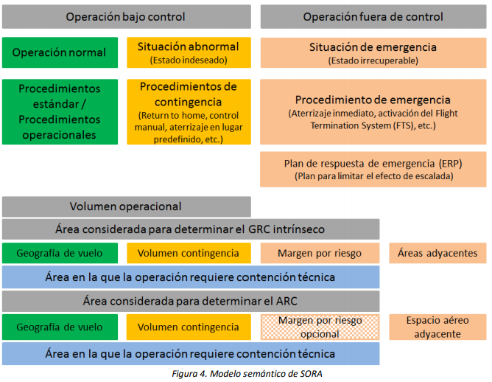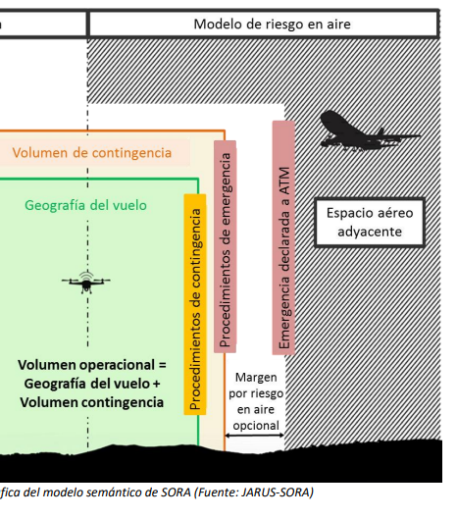

|  |  |  |  |  |  |  |  |
| --- | --- | --- | --- | --- | --- | --- | --- |
|  | Maximum flight geography  (distances in metres) | | Minimum contingency volume  (distances in metres) | | Minimum air risk buffer  (distances in metres) | | Remarks |
| Horizontal* | Vertical | Horizontal | Vertical | Horizontal | Vertical |
| UAS 1 |  |  |  |  |  |  |  |
| UAS 2 |  |  |  |  |  |  |  |
| UAS n |  |  |  |  |  |  |  |

(*) Represents the radius of the volume, that is, the distance from the pilot to the UAS.

# STRATEGIC AND TACTICAL MITIGATIONS FOR UAS OPERATIONS IN GENERAL UAS GEOGRAPHICAL ZONES FOR OPERATIONAL SAFETY REASONS IN CONTROLLED AIRSPACE

Operations with UAS carried out in controlled airspace must comply with the requirements set out in Chapter V of Royal Decree 517/2024, and with the measures determined by the ATSP for this type of operation to guarantee the safety and continuity of air operations.

|  |  |  |  |
| --- | --- | --- | --- |
| **COD.** | **TYPE OF MITIGATION** | **MITIGATION MEASURE** | **OBSERVATIONS** |
|
| MAE01 | Strategic | Have an appropriate **communication device** capable of supporting two-way communication with aeronautical stations and on the frequencies indicated to meet the requirements applicable to the airspace in question. | Art. 43.6.a RD UAS 517/2024  At the discretion of the ATS provider and/or the aerodrome or heliport manager  As determined in the pre-tactical coordination |
| MAE02 | Strategic | Have a theoretical training certificate as a radio operator issued by the National Aviation Safety Agency (AESA) and a practical training certificate as a radio operator issued by an examiner authorised by AESA; or  Have the knowledge necessary to obtain a radio operator certification, accredited by means of a rating annotated on a pilot licence or certification issued by an approved training organisation (ATO) or an ultra-light school in accordance with Article 33 (1) (e) of Royal Decree 1036/2017 (*Valid until 25/06/2026) | Art. 34.1.a RD UAS 517/2024  First transitional provision of Royal Decree UAS 517/2024 (*Valid until 25/06/2026) |
| MAEXX/MATXX | XXXX | XXXX | XXX |

# PROCEDURE TO COORDINATE OPERATIONS WITH ATSP

Next, the following instructions are agreed to carry out each of the air operations planned by the UAS operator in the controlled airspace:

|  |  |
| --- | --- |
| ARCID* callsign | EXAMPL# |
| Callsign*\** | EXAMPLE## |
| Language to be used in aeronautical communication | SPANISH/ENGLISH |
| Primary means of communication | AIR RADIO / MOBILE PHONE |
| Alternative means of communication | AIR RADIO / MOBILE PHONE |
| NOTAM publication request | Outside **general UAS geographical zones for operational safety reasons** in the vicinity of aerodromes:NO**  Inside **general UAS geographical zones for operational safety reasons** in the vicinity of aerodromes:AT THE DISCRETION OF THE ATS UNIT |

*Subject to modification during the tactical coordination or by the ATCO/AFISO during operations on the basis of its powers.

(**) However, it may be required in the pre-tactical or tactical phase of the coordination process if deemed appropriate for the proper execution of the operation.

Procedure to be followed by the UAS operator to carry out any flight as per the coordinated ConOps:

Flow chart of specific operations for this ConOps prepared by the ATSP, detailing the instructions, arranged chronologically, to be followed by the UAS operator to carry out a specific operation.

1. If coordination with the aerodrome manager is required as per mitigation measure MAE09, the airport manager must be contacted at least 20 business days before the operation.
2. At least **10 business days[2]** before the operation, present to the ATSP:
   * Copy of evidence of EARO coordination (this document) signed by both parties.
   * Specific details of the operation
     + Specific place.
     + Date and time.
3. The day before the operation (recommended) or up to 60 minutes before the start time of the operation, file a flight plan (FPL) with air traffic services as per the ENAIRE guide, available on its website.

(https://www.enaire.es/servicios/drones/lo_necesario_para_volar_tu_dron/volar_espacio_aereo_controlado_enaire)

1. Before the flight:
   * Make sure the ATS flight plan has been filed correctly
   * Pre-Flight Information Bulletin (PIB) and/or NOTAM and meteorology in the operations area.
2. 30 minutes before the start of operations: contact ATC/AFIS to confirm the operation.
   * In the first communication, the pilot will report the reference number of the aerial work in question (REF. ENAIRE XXX / Callsign XXX), which must include the words “NO TRIPULADO” or “UNMANNED” in the communication.
3. Before starting the flight: contact the ATCO/AFISO to obtain flight (take-off) clearance or to report take-off.
4. After completing the operation:
   * contact the ATCO/AFISO and report completion of the operation
   * report closing the ATS flight plan by calling the corresponding ARO office.
   * Report the completion and/or cancellation of operations to the COOP.

# SPECIFIC PROCEDURES IN ABNORMAL AND EMERGENCY SITUATIONS

The UAS operator shall adopt the following procedures in the event of abnormal and emergency situations:

|  |  |
| --- | --- |
| EVENT | PROCEDURE |
| Loss of communication with the ATSP (radio failure) | * If the communication failure is detected by the ATS unit:   - Establish communication on the alternative means (landline or mobile phone), reporting the radio communication failure. Assess the continuity or cancellation of the UAS operations.   * If the communication failure is detected by the UAS operator:   - Maintain situational awareness by monitoring the airspace and “seeing and avoiding”.  - Establish communication on the alternative means (landline or mobile phone), report the radio communication failure and proceed as instructed by ATS.  - If the operator is unable to establish communication by any means, the flight must be immediately terminated and the aircraft landed in a safe place.  - Notify the ATS unit as soon as possible of the end of the activity using the relevant alternative means and cancel the ATS flight plan.  - If communication is re-established, the UAS operator must obtain ATC clearance or AFIS communication once more to start a new flight. |
| Loss of control of the UAS (fly away) | If it is not possible to regain control and/or the position of the UAS is unknown:  - Consider activating the fail-safe system of the UAS as per the operator's procedures.  - Notify ATS of the loss of control and position of the UAS as soon as possible by radio/telephone:  - Callsign + “no tripulado” or “unmanned”  - Emergency due to loss of control of the unmanned aircraft  - Last known position, speed, direction and height/altitude  - Battery life remaining  - Report the end of the emergency to ATS when the operator knows that the UAS is no longer airborne or is sure that it cannot still be airborne (the maximum flight time of the UAS has been exceeded) |
|  | OTHER |

The contact addresses for notifications in the event of abnormal or emergency situations are provided below:

|  |  |
| --- | --- |
| Position | Contact |
| ATS (civil/military) unit | Frequency / TEL // Depends on unit in question. Provided during the preliminary coordination |
| ENAIRE'S Airspace Operations Coordination Department (COOP) | ENAIRE PLANEA / [cop@enaire.es](mailto:cop@enaire.es) |
| Airport Management Centre (CGA) / Airport Operations / Military Base | Depends on the unit in question. Contact information provided during the preliminary coordination |
| Emergencies | 112 |

# EVIDENCE OF COORDINATION AND VALIDITY

This coordination is valid indefinitely, subject to the proper implementation of the mitigation measures and compliance with the established limits or conditions of the operation, for as long as such compliance is maintained. Any modification to or deviation from what is indicated herein will require a new agreement. When there are justified reasons, the ATSP reserves the right to amend these conditions or revoke the agreement.

In witness of conformity and evidence of coordination, both parties provide their consent to this document:

|  |  |
| --- | --- |
| **The operator** | **The Air Traffic Service Provider** |
| XXX, _______ 202_ | Madrid, ___ ______________ 202_ |
| Signature | Signature/stamp |
| Position | ENAIRE Operational Safety Technical |
| FULL NAME |

# ANNEX I. GENERAL UAS GEOGRAPHICAL ZONES FOR OPERATIONAL SAFETY REASONS IN THE VICINITY OF CIVIL OR MILITARY AIRPORTS AND HELIPORTS

This risk assessment and coordination of operations will be valid provided that the **flight geography and its associated contingency volume**, as per the semantic model described, are **inside and/or outside the general UAS geographical zones for operational safety reasons in the vicinity of civil or military airports and heliports** defined below**:**

a) In civil aerodromes for public use and military aerodromes of any type other than heliports:

1) **Up to 45 metres in altitude** measured from the Aerodrome Reference Point (ARP): an area of 6 kilometres long, measured outward from the ends of the runway along the extended runway centreline, and 5 kilometres wide on both sides measured from the runway centreline. In any case, the lower limit of this volume will be the level of the surface.

2) **Above 45 metres and up to 900 metres in altitude**, both measured from the ARP: an area of 10 kilometres long, measured outward from the ends of the runway along the extended runway centreline, and 7.5 kilometres wide on both sides measured from the runway centreline.

b) In heliports for public and military use:

1) **Up to 90 metres in altitude** measured from the Heliport Reference Point (HRP): an area of 2.5 kilometres long, measured outward from the ends of the Final Approach and Takeoff Area(FATO) along the extended FATO centreline, and 2.5 kilometres wide on both sides measured from the FATO centreline.In any case, the lower limit of this volume will be the level of the surface.

2) **Above** **90 metres and up to 900 metres in altitude**, both measured from the HRP: an area of 3.3 kilometres long, measured outward from the ends of the FATO along the extended FATO centreline, and 3.3 kilometres wide on both sides measured from the FATO centreline.

c) In restricted-use aerodromes that are not heliports:

1) **Up to 45 metres in altitude** measured from the ARP: an area of 3 kilometres long, measured outward from the ends of the runway along the extended runway centreline, and 3 kilometres wide on both sides measured from the runway centreline. In any case, the lower limit of this volume will be the level of the surface.

2) **Above 45 metres and up to 900 metres in altitude**, both measured from the ARP: an area of 5 kilometres long, measured outward from the ends of the runway along the extended runway centreline, and 4.5 kilometres wide on both sides measured from the runway centreline.

d) In restricted-use heliports:

1) **Up to 90 metres in altitude**, measured from the HRP: a circular area of with a 2.5-kilometre radius from the centre of the FATO. In restricted heliports with a FATO landing runway over 100 metres long, the above distance shall be considered measured from each end of the FATO. In any case, the lower limit of this volume will be the level of the surface.

2) **Above 90 metres and up to 450 metres in altitude**, both measured from the HRP: a circular area of with a 3.3-kilometre radius from the centre of the FATO. In restricted heliports with a FATO landing runway over 100 metres long, the above distance shall be considered measured from each end of the FATO.

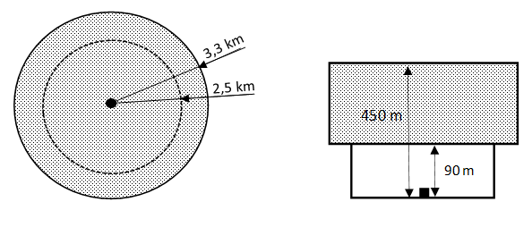

# ANNEX II. EVIDENCE OF COMPLIANCE WITH THE MITIGATION MEASURES

This Annex provides evidence of the implementation of the following mitigation measures:

* **MAE10.** Have procedures for consulting and analysing the different departure and arrival procedures in the AIP for the airport in question based on its possible operational configurations (runway in use), including missed approaches and take-offs with an engine failure. Operations must be carried out by personnel who have the necessary skills to comply with the query and interpretation mitigations of the FLIGHT PROCEDURES.

Airport **departure** procedures __________________

INSERT IMAGE

Airport **arrival** procedures _______________

INSERT IMAGE

* **MAE20 and MAT01.** Have procedures for checking activities and warnings for airspace users (NOTAM) in the planned operations area.

Operations must be carried out by personnel who have the necessary skills to comply with the query and interpretation mitigations of the NOTAM, ATIS and DATIS.

As applicable, the ENAIRE DRONES application and the INSIGNIA, AIP, ICARO XXI platforms may be used, and specifically the “BOL” Bulletins feature of the latter, with all the information of interest with regard to an aerodrome or operations zone.

To provide proof of the above measures, we request screenshots of: ENAIRE DRONES/ICARO XXI and ATIS frequencies.

Screenshot of the NOTAM page in [ENAIRE Drones](https://drones.enaire.es/):

INSERT IMAGE

Screenshot of ATIS check:

INSERT IMAGE

# ANNEX III. ABBREVIATIONS

|  |  |
| --- | --- |
| AESA | National Aviation Safety Agency |
| AIP | Aeronautical Information Publication |
| ANSP | Air Navigation Service Provider |
| ATSP | Air Traffic Service Provider |
| ATS | Air Traffic Services |
| ATC | Air Traffic Control |
| ATZ | Air Traffic Zone |
| AFIS | Aerodrome Flight Information Services |
| ATCO | Air Traffic Control Officer |
| AFISO | Aerodrome Flight Information Services Officer |
| ConOps | Concept of Operations |
| COOP | ENAIRE'S Airspace Operations Coordination Department |
| CTR | Controlled Traffic Region |
| FPL | Flight plan |
| MTOM | Maximum Take-Off Mass |
| NOTAM | NOTice to AirMen (notice containing information concerning the establishment, condition or change in any aeronautical facility, service, procedure or hazard, the timely knowledge of which is essential to personnel concerned with flight operations) |
| PIB | Pre-flight Information Bulletins |
| STS | Standard Scenario |
| STS-ES | National Standard Scenario |
| UA | Unmanned Aircraft |
| UAS | Unmanned Aircraft System |
| VLOS | Visual Line of Sight |

1. General UAS geographical zones for operational safety reasons in the vicinity of civil or military airports and heliports, for the purposes of evaluating the risk and coordinating operations with UAS in controlled airspace. These distances, based on the obstacle limiting areas around aerodromes, are detailed in the annex to this document and are independent of the requirement to coordinate operations with the facility manager contained in Article 42.2.b of Royal Decree 517/2024. In consequence, this coordination will not be valid outside these zones, in VLOS condition, and below 60 m height.
2. Exclusively **for urgent operations that present a public service of interest to society (e.g. search and rescue, infrastructure inspections in critical situations, firefighting, security, etc.) ENAIRE has a specific procedure to which the operators carrying out such operations can subscribe**. They can apply for it by contacting COOP through the mailbox: coop.org.oficiales@enaire.es.